**Thomas Killeen C16394453 DT228 2**

For the assignment we were required to design a website that utilised the uses of HTML, PHP, and databases. We were tasked to build a website that allowed a user to login, register a new user, view books available, search for a book, reserve a book and view reserved books. I knew this was going to be a challenge from the start, so I decided to draw an outline of what I wanted my site to look like and what features I wanted it to have. I decided to make the site as user friendly as possible with easy navigation and soft colours. I also wanted to design the site so that the code was easy to read and not too cluttered, so I split the pages up utilizing separate pages for most of the php work. I also made sure to follow the guidelines of the brief. I created a database through phpmyadmin and created a database called library with four tables called, book, category, reservations and users. They have all the data outlined in the brief and extra ones I added.

**Startingpage.html**

The first page is the starting page (Startingpage.html). I decided to make the first page a html file as the starting page is simply just two links to login.php and registration.php. I did this as I was having a lot of issues with having two forms on the same page sending out information to separate php files and I was also having trouble with having the php code on the same page. So, I decided to split them up to iron out any serious issues that could go wrong. When designing the page, I had a relaxing kind of approach to the design, so the colours are soft, and the font is easy to read.

Code:

<!DOCTYPE html>

<!-- Assignmet 08/11/2017 TK -->

<html>

<head>

<title>Thomas Killeen</title>

<meta charset="UTF-8">

<meta name="keywords" content="Starting page, links">

<meta name="description" content="A starting page which links to two seperate pages">

<meta name="author" content="Thomas Killeen">

<link rel="stylesheet" type="text/css" href="./css/mystyles.css">

</head>

<body>

<header>Library Reservation</header>

<div>

<a href="./login.php">Login</a>

<a href="./regestration.php">Register</a>

</div>

<footer><p>Copyright&copy; Thomas Killeen <q>The main man!</q>&trade;</p></footer>

</div>

</html>

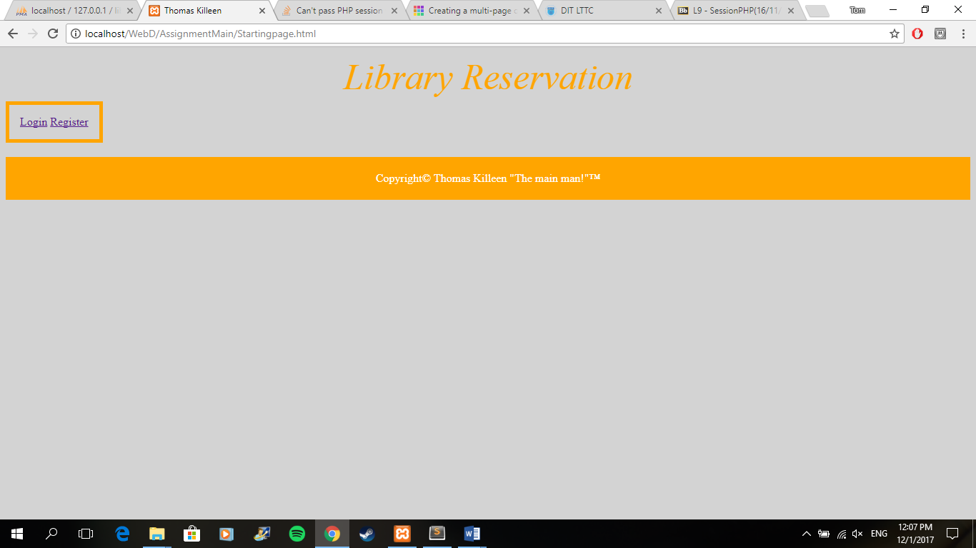

**Login.php**

login.php contains a login form which allows the user to login to an account created in the database library from logging in with one of the user profiles on the table users. When the form is submitted it connects to the database library and checks the user’s username and password from the users table from the library database and compares them with the details entered through the form. If the details match, then a session starts, and the user is sent to hompage.php which is the core site. If the user’s details do not match, then the user is sent back to the login.php and the session stops. There is some small error checking with the form that has required tag in the forms inputs. This stops the user from accessing anything they shouldn’t.

Code:

<!DOCTYPE html>

<!-- Assignmet 08/11/2017 TK -->

<html>

<head>

<title>Thomas Killeen</title>

<meta charset="UTF-8">

<meta name="keywords" content="login, data, form">

<meta name="description" content="A page that allows the user to login to the site">

<meta name="author" content="Thomas Killeen">

<link rel="stylesheet" type="text/css" href="./css/mystyles.css">

</head>

<body>

<header>Library Reservation</header>

<?php

//Creates a connection to the database library

$con=mysqli_connect('localhost','','','library');

//Tests connection to see if it has connected

if (mysqli_connect_errno($con))

{

echo "failed to connect";

}

//The variable result creates a query statement to get information from the users table

$result = mysqli_query($con,"SELECT * FROM users WHERE Username = '".$_POST['username']."' AND Password = '".$_POST['password']."'");

//Creates a count variable from the num rows from the variable result

$count = mysqli_num_rows($result);

if($count == 1)

{

session_start();//Starts a session

$_SESSION["username"] = $_SESSION["username"]+1;//Creates a session variable by the username added +1 to access an if

header( 'Location: homepage.php' ) ;//Moves the user to the next php page

}

else

{

$_SESSION["error"] = "Missing Required Information";//If there was an error with required information

}

mysqli_close($con);//Closes connection

?>

<form id="username" action="login.php" method="post">

<fieldset>

<legend>Login</legend>

Username:<br>

<input type="text" name="username" placeholder="Username">

<br>

Password:<br>

<input type="password" name="password" placeholder="Password">

<br><br>

<input type="submit" name="Submit" value="Submit">

</fieldset>

</form>

<div>

<a href="./StartingPage.html">Back to starting page</a>

</div>

<footer><p>Copyright&copy; Thomas Killeen <q>The main man!</q>&trade;</p></footer>

</body>

</html>

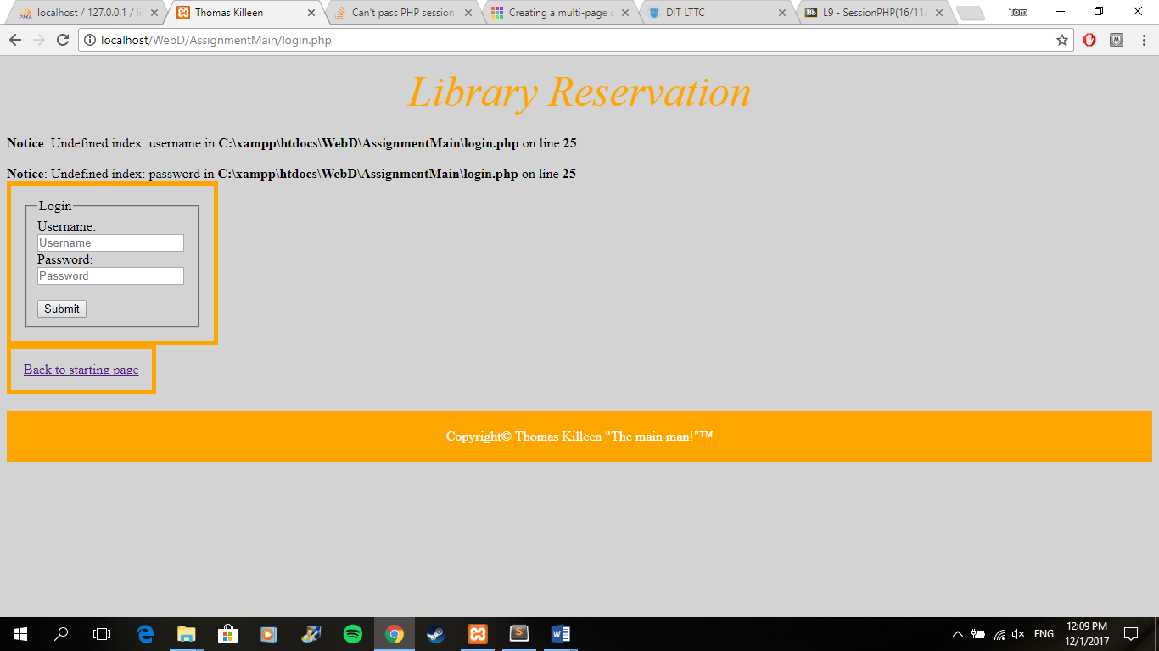

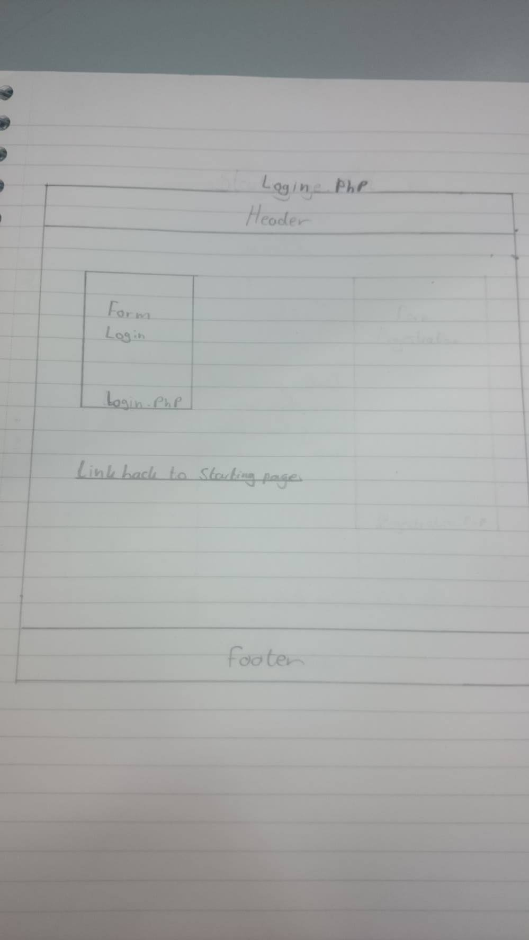

**Regestration.php**

registration.php contains a form to register a new user. When the details have been entered into the form it connects to the database library and accesses the users table. The file then creates a varriable $sql and inserts the data taken by the form into users table in the library table. The file then brings the user back to startingpage.html and the can then login or register another user from there. There is some small error checking with the form that has required tag in the forms inputs. This stops the user from not adding enough data to the tables.

**Code:**

**<!DOCTYPE html>**

<!-- Assignmet 08/11/2017 TK -->

<html>

<head>

<title>Thomas Killeen</title>

<meta charset="UTF-8">

<meta name="keywords" content="Regestration, data, form">

<meta name="description" content="A page that allows the user to register a new user">

<meta name="author" content="Thomas Killeen">

<link rel="stylesheet" type="text/css" href="./css/mystyles.css">

</head>

<body>

<header>Library Reservation</header>

<?php

//Creates a connection to the database library

$con=mysqli_connect('localhost','','','library');

//Tests connection to see if it has connected

if (mysqli_connect_errno($con))

{

echo "failed to connect";

}

//Creates a variable called sql that inserts the information given by the form into the table users

$sql = "INSERT INTO users (Username, Password, FirstName, Surname, AddressLine, City, Telephone, Mobile)

VALUES

('$_POST[username]', '$_POST[password]', '$_POST[firstname]', '$_POST[lastName]', '$_POST[address]

', '$_POST[city]', '$_POST[phoneno]', '$_POST[mobileno]')";

if(!mysqli_query($con,$sql))

{

die('Error: ' . mysqli_error());

}

mysqli_close($con);

?>

<form id="fullname" method="post">

<fieldset>

<legend>Sign up</legend>

Username:<br>

<input type="text" name="username" required placeholder="Username">

<br>

Password:<br>

<input type="password" name="password" required placeholder ="Password">

<br>

First Name:<br>

<input type="text" name="firstname" required placeholder="First Name">

<br>

Last Name:<br>

<input type="text" name="lastName" required placeholder ="Last Name">

<br>

Address:<br>

<input type="text" name="address" required placeholder ="Address">

<br>

City:<br>

<input type="text" name="city" required placeholder ="city">

<br>

Phone No:<br>

<input type="number" name="phoneno" required placeholder="Phone No">

<br>

Mobile No:<br>

<input type="number" name="mobileno" required placeholder="Phone No">

<br><br>

<input type="submit" name="Submit" value="Submit">

</fieldset>

</form>

<div>

<a href="./StartingPage.html">Back to starting page</a>

</div>

<footer><p>Copyright&copy; Thomas Killeen <q>The main man!</q>&trade;</p></footer>

</body>

</html>

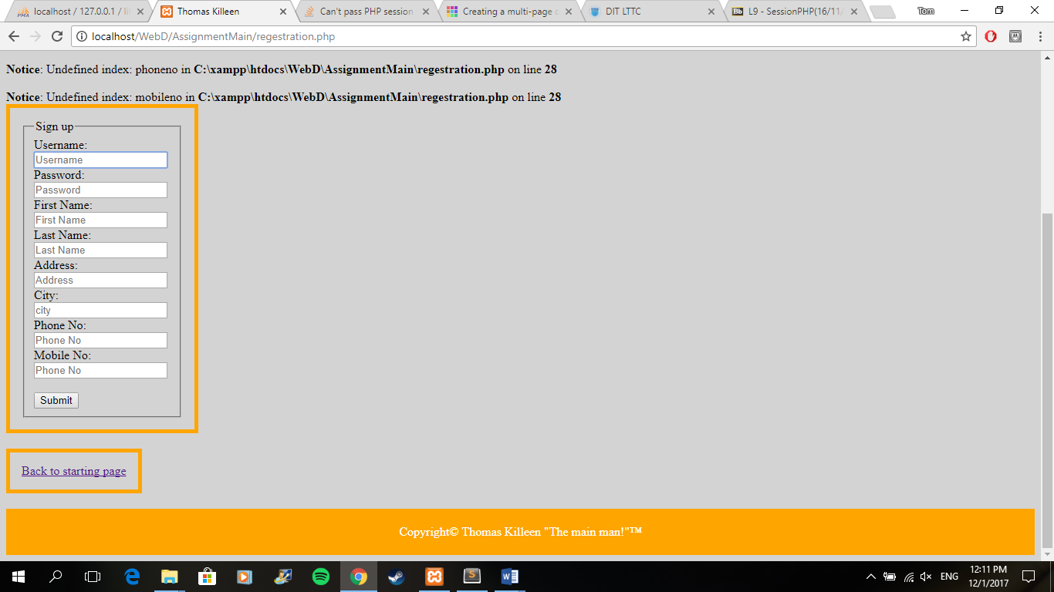

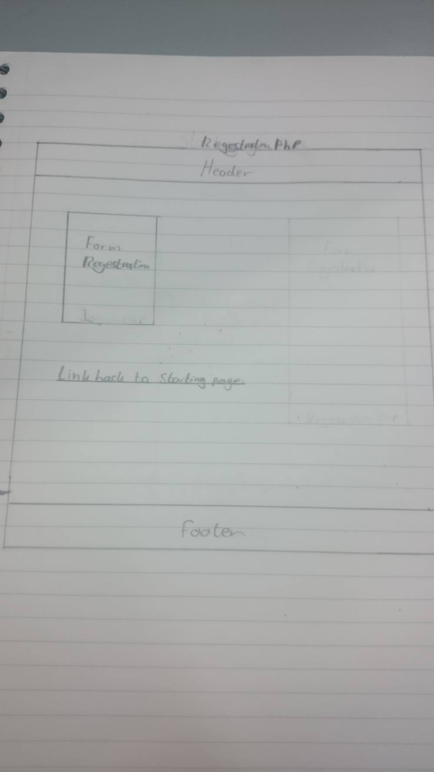

**Homepage.php**

homepage.php is the main part of the site. This is the page the user is brought to when the user logs in to the website. The page itself is the outline for the following pages as the footer, header and menu are all consistent with the rest of the pages. The site first connects to the database. The page itself contains a menu contains links to the hompage itself, searchforms.html which will bring the user to the search system, and view.php which will bring the user to the reserved books. There is also a clickable link down the bottom of the page called logout which goes to logout.php again with no interface for the user and ends the session and brings the user back to startingpage.html.

**Code:**

<!DOCTYPE html>

<!-- Assignmet 08/11/2017 TK -->

<html>

<head>

<title>Thomas Killeen</title>

<meta charset="UTF-8">

<meta name="keywords" content="homepage, links">

<meta name="description" content="A page that links to other pages on the site">

<meta name="author" content="Thomas Killeen">

<link rel="stylesheet" type="text/css" href="./css/mystyles.css">

</head>

<body>

<header>Library Reservation</header>

<nav>

<ul id= "menu" class="menu">

<li><a href="./homepage.php">Homepage</a></li>

<li><a href="./search.php">Search</a></li>

<li><a href="./View.php">View Reserved Books</a></li>

</ul>

</nav>

<?php

session_start();

?>

<div>

<p><a href="./logout.php">Logout</a></p>

</div>

<footer><p>Copyright&copy; Thomas Killeen <q>The main man!</q>&trade;</p></footer>

</body>

</html>

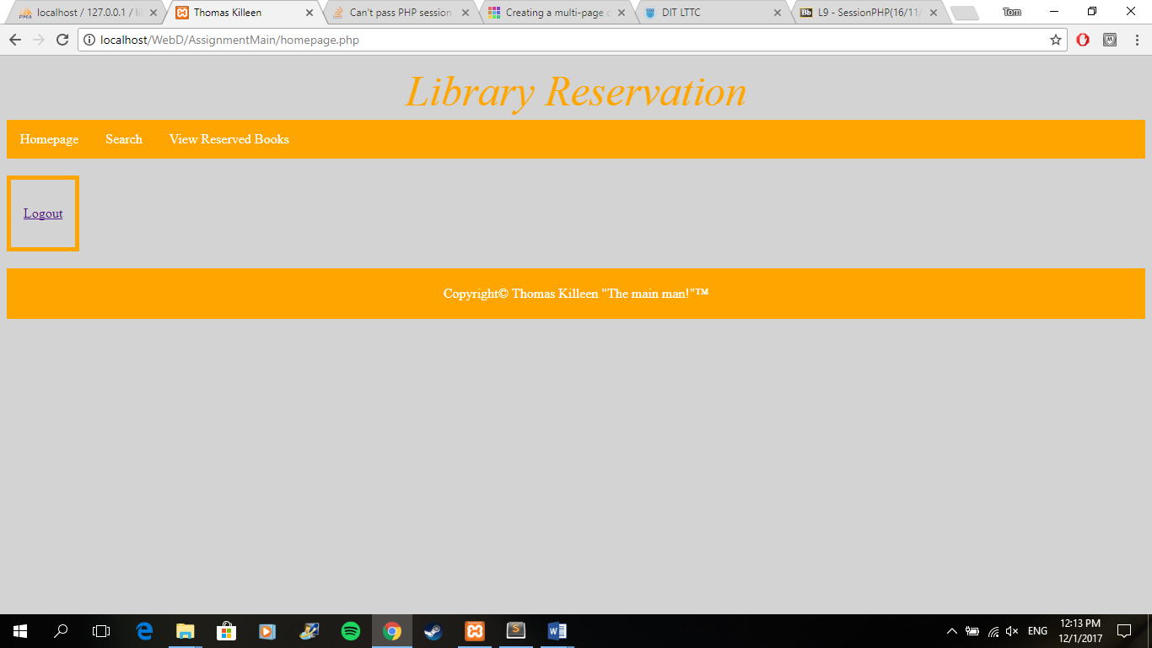

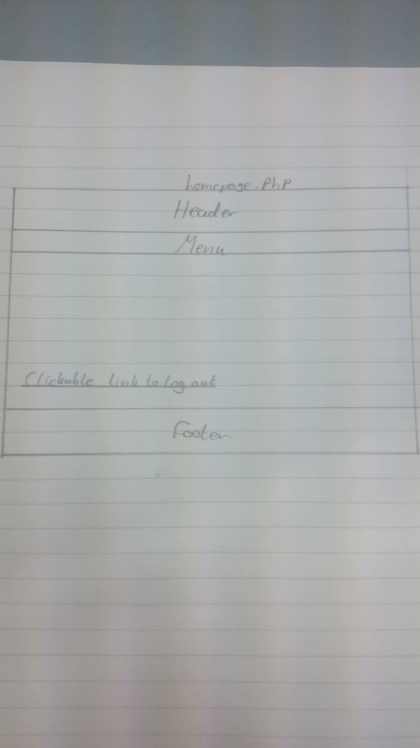

**Reserve.php**

reserve.php is the file that will reserve the book for the user. It does not have an interface as it connects to the database and changes the data. The file changes the reserved query in the book table to Y when it is reserved and adds the book through the ISBN number to the reserved book table. The file then connects back to the homepage.

**Code:**

<!DOCTYPE html>

<!-- Assignmet 08/11/2017 TK -->

<html>

<head>

<title>Thomas Killeen</title>

<meta charset="UTF-8">

<meta name="keywords" content="reserve">

<meta name="description" content="Php to reserve a book, does not work">

<meta name="author" content="Thomas Killeen">

<link rel="stylesheet" type="text/css" href="./css/mystyles.css">

</head>

<body>

<?php

//Connect to database library

$con=mysqli_connect('localhost','','','library');

//If there was a failure connecting to the library

if (mysqli_connect_errno($con))

{

echo "failed to connect";

}

//The variable result gets all from the table book

$result = mysqli_query($con,"SELECT * FROM book");

if(isset($_GET['ISBN']) && isset($_GET['Reserved']))//If the information from the previous page matches

{

$is = mysqli_real_escape_string($_POST['ISBN']);//Creates a variable for the ISBN

$sql = "UPDATE book set Reserved = 'Y' where ISBN = '$IS'";//Updates the table from where the ISBN is the same and changes the reserved to Y

mysql_query($sql);

$sql = "INSERT INTO Reservations (ISBN, Username, ReservedDate)

VALUES ('$IS', '$_SESSION[Username]', '11-OCT-2008');";//Then inserts the values into the Reservations table

return;

header( 'Location: homepage.php');

}

?>

</body>

</html>

**Search.php**

search.php contains two separate forms that allows the user to check for a book by text input with BookName and Author, and the second form allows the user to search for a book by option drop down. When a form is submitted it connects to the database. Once done the data on the form is compared to the data from the book table. When the book is found it will display the book and allow the user to reserve the book through a link. It is the same way that books are displayed on the homepage only this time in a singular way. If the book is not found it will prompt an error. The page has the same menu, header, footer and logout as the pages before have. I wasn’t able to get a partial search working, I kept on getting errors so I decided to omit it so I could focus on having a working system.

**Code:**

<!DOCTYPE html>

<!-- Assignmet 08/11/2017 TK -->

<html>

<head>

<title>Thomas Killeen</title>

<meta charset="UTF-8">

<meta name="keywords" content="search, book">

<meta name="description" content="Alows the user to search for books">

<meta name="author" content="Thomas Killeen">

<link rel="stylesheet" type="text/css" href="./css/mystyles.css">

</head>

<body>

<header>Library Reservation</header>

<nav>

<ul id= "menu" class="menu">

<li><a href="./homepage.php">Homepage</a></li>

<li><a href="./search.php">Search</a></li>

<li><a href="./View.php">View Reserved Books</a></li>

</ul>

</nav>

<?php

session_start();

//Connect to database library

$con=mysqli_connect('localhost','','','library');

//If there was a failure connecting to the library

if (mysqli_connect_errno($con))

{

echo "failed to connect";

}

//Creates a variable to get the required information from the form and table book

$result = mysqli_query($con,"SELECT * FROM book WHERE BookTitle = '".$_POST['Booktitle']."' AND Author = '".$_POST['Authorname']."'");

$count = mysqli_num_rows($result);//Creates a count for the number of tables needed

if($count == 1)

{

echo '<table border="1">'."\n";//Creates a table

while ( $row = mysqli_fetch_array($result,MYSQLI_ASSOC) )//gets the info from the results variable

{

echo "<tr><td>";

echo $row['ISBN'];

echo("</td><td>");

echo $row['BookTitle'];

echo("</td><td>");

echo $row['Author'];

echo("</td><td>");

echo $row['Edition'];

echo("</td><td>");

echo $row['Year'];

echo("</td><td>");

echo $row['Category'];

echo("</td><td>");

echo $row['Reserved'];

echo("</td><td>");

echo('<a href="./reserve.php?id=reserve.php'.htmlentities($row['ISBN'], $row['BookTitle'], $row['Author'], $row['Edition'], $row['Year'], $row['Category'], $row['Reserved']).'">Reserve</a>');//Provides a link to reserve

echo("</td></tr>\n");

}

echo "</table>\n";//Ends the table

}

else

{

$_SESSION["error"] = "Missing Required Information";

}

?>

<?php

$result1 = mysqli_query($con,"SELECT * FROM book WHERE Category = '".$_POST['type']."'");

$count1 = mysqli_num_rows($result);

if($count == 1)

{

echo '<table border="1">'."\n";

while ( $row = mysqli_fetch_array($result1,MYSQLI_ASSOC) )

{

echo "<tr><td>";

echo $row['ISBN'];

echo("</td><td>");

echo $row['BookTitle'];

echo("</td><td>");

echo $row['Author'];

echo("</td><td>");

echo $row['Edition'];

echo("</td><td>");

echo $row['Year'];

echo("</td><td>");

echo $row['Category'];

echo("</td><td>");

echo $row['Reserved'];

echo("</td><td>");

echo('<a href="./reserve.php'.htmlentities($row['ISBN'], $row['BookTitle'], $row['Author'], $row['Edition'], $row['Year'], $row['Category'], $row['Reserved']).'">Reserve</a>');

echo("</td></tr>\n");

}

echo "</table>\n";

}

else

{

$_SESSION["error"] = "Missing Required Information";

}

?>

<form id="search" method="post">

<fieldset>

<legend>Search for a book</legend>

Author Name:<br>

<input type="text" name="Authorname" placeholder="Author Name">

<br>

Book Title:<br>

<input type="text" name="Booktitle" placeholder="Book Title">

<br><br>

<input type="submit" name="Submit" value="Submit">

</fieldset>

</form>

<form id="search" method="post">

<fieldset>

Category:<br>

<select name="type">

<option value="1">Health</option>

<option value="2">Business</option>

<option value="3">Biography</option>

<option value="4">Technology</option>

<option value="5">Travel</option>

<option value="6">Self Help</option>

<option value="7">Cookery</option>

<option value="8">Fiction</option>

</select>

<br><br>

<input type="submit" name="Submit2" value="Submit">

</fieldset>

</form>

<div>

<p><a href="./Logout.php">Logout</a></p>

</div>

<footer><p>Copyright&copy; Thomas Killeen <q>The main man!</q>&trade;</p></footer>

</body>

</html>

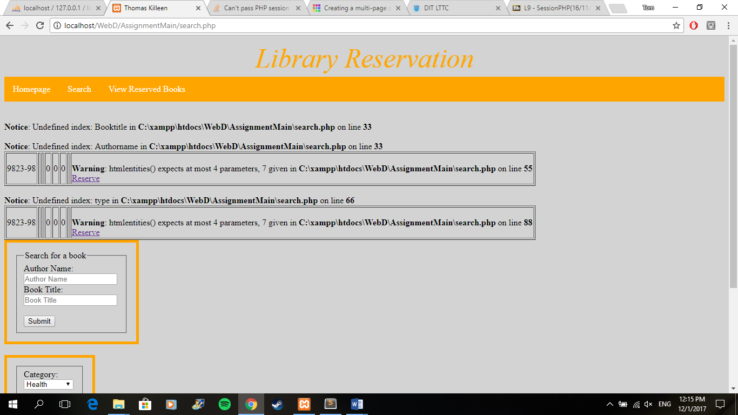

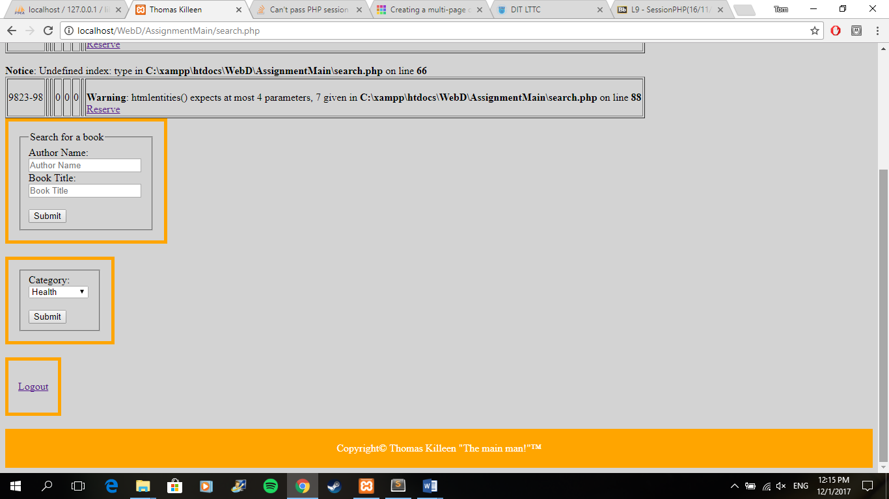

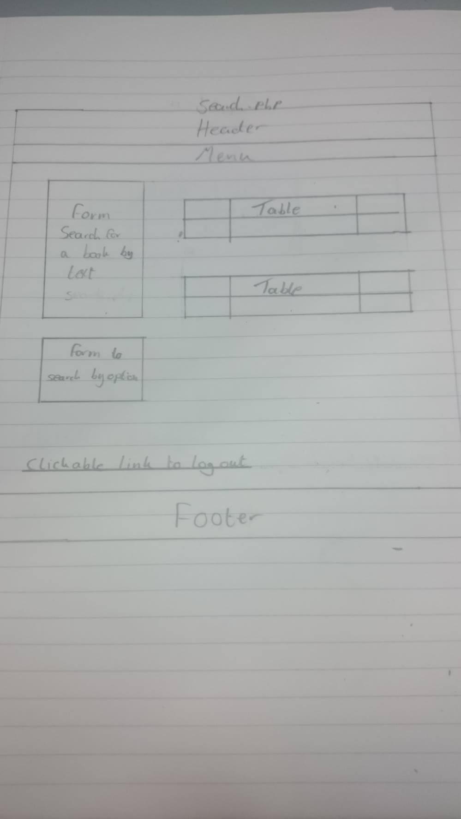

**View.php**

view.php starts off by connecting to the database. The file then prints the contents of the table reservations from the library database. It is based on the same system that I implemented in the homepage file. The page has the same menu, header, footer and logout link as the other pages.

**Code:**

<!DOCTYPE html>

<!-- Assignmet 08/11/2017 TK -->

<html>

<head>

<title>Thomas Killeen</title>

<meta charset="UTF-8">

<meta name="keywords" content="view, reserved">

<meta name="description" content="Shows the user what books are reserved">

<meta name="author" content="Thomas Killeen">

<link rel="stylesheet" type="text/css" href="./css/mystyles.css">

</head>

<body>

<header>Library Reservation</header>

<nav>

<ul id= "menu" class="menu">

<li><a href="./homepage.php">Homepage</a></li>

<li><a href="./search.php">Search</a></li>

<li><a href="./View.php">View Reserved Books</a></li>

</ul>

</nav>

<?php

//Connect to database library

session_start();

$con=mysqli_connect('localhost','','','library');

//If there was a failure connecting to the library

if (mysqli_connect_errno($con))

{

echo "failed to connect";

}

echo '<table border="1">'."\n";//Creates a table

$result = mysqli_query($con,"SELECT * FROM reservations");//creates a variable that contains everything from the reservations table

while ( $row = mysqli_fetch_array($result) )//Shows the ammount in the table

{

echo "<tr><td>";

echo $row['ISBN'];

echo("</td><td>");

echo $row['Username'];

echo("</td><td>");

echo $row['ReservedDate'];

echo("</td></tr>\n");

}

echo "</table>\n";//Ends table

?>

<div>

<p><a href="./Logout.php">Logout</a></p>

</div>

<footer><p>Copyright&copy; Thomas Killeen <q>The main man!</q>&trade;</p></footer>

</body>

</html>

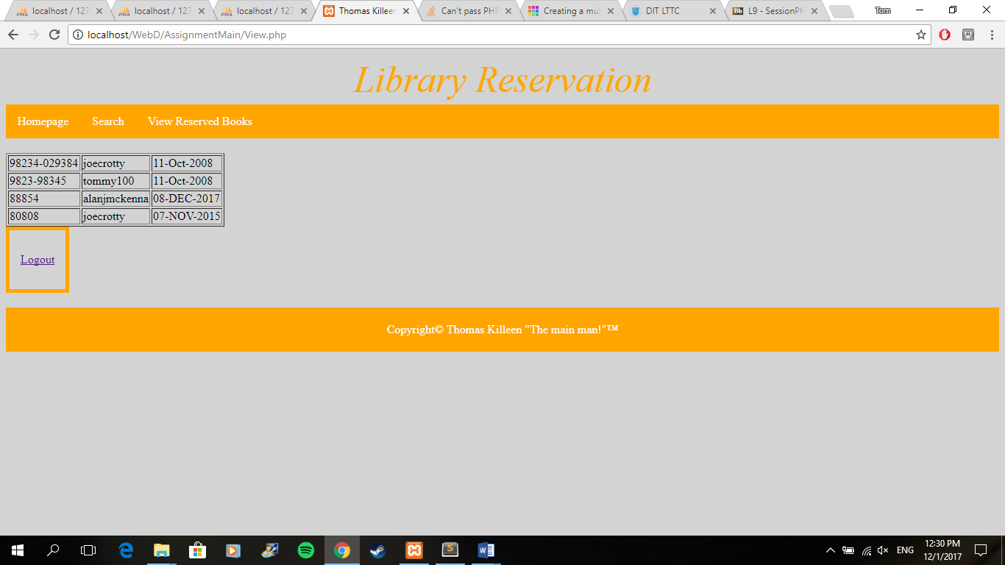

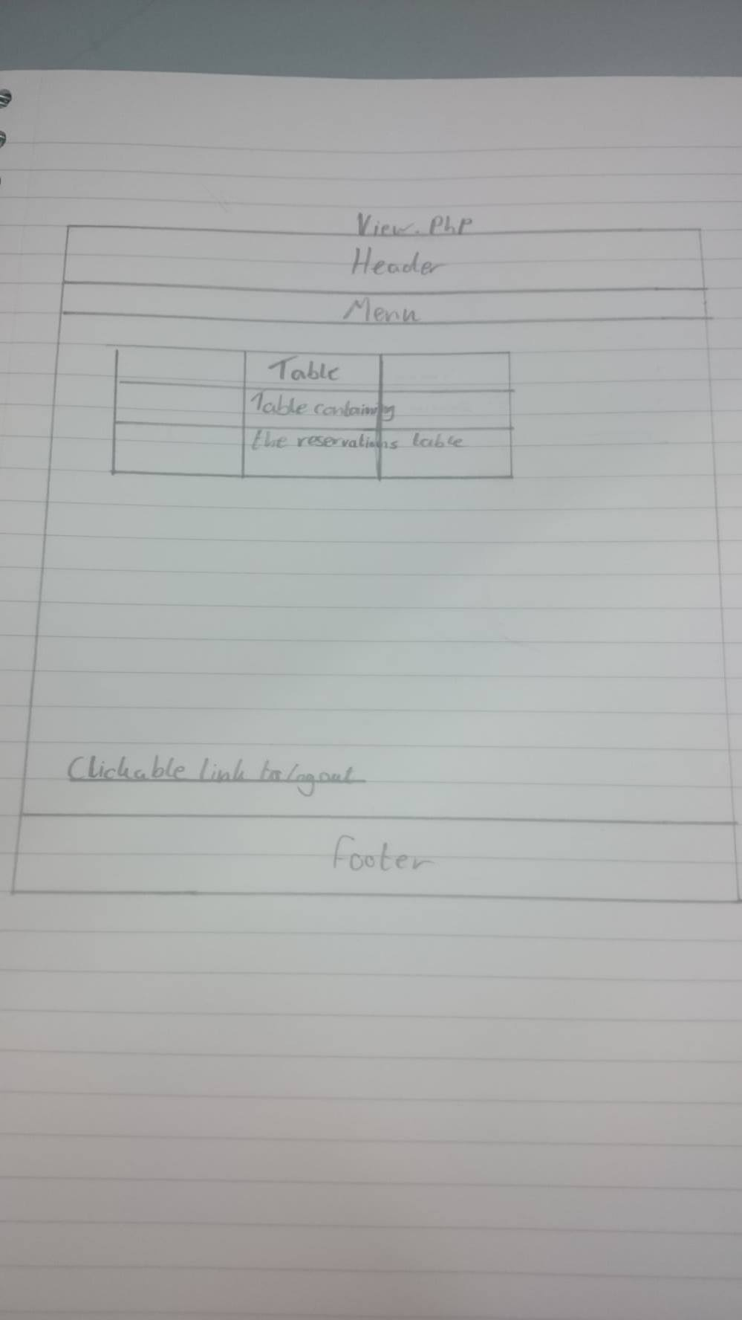

**Logout.php**

logout.php is a file that will go to a page that does not have an interface. It is a simple page that just ends the session which essentially logs the user out, so they can’t get back to the core pages without logging back in to the system by starting a new session. The file links back to startingpage.html.

**Code:**

<!DOCTYPE html PUBLIC "-//W3C//DTD XHTML 1.0 Transitional//EN"

"http:www.w3.org/TR/xhtml1/DTD/xhtml1-transitional.dtd">

<html xmlns="http//www.w3.org/1999/xhtml" xml:lang="en" lang"en">

<head>

<meta http-equiv="content-type" content="text/html;charset=iso-8859-1"/>

<title>WebDb</title>

</head>

<body>

<?php

//This will end the session and bring the user back to the starting page

session_start();

session_destroy();

header("Location: Startingpage.html");

?>

</body>

</html>

**CSS**

mystyles.css is simply the stylesheet. The stylesheet is connected to each page for consistency. The styles are simple as I didn’t want too much of an over use of css as I wanted the design to be simple and user friendly. The css consists of styles to items that are consistent on each page such as the menu, header and footer. There is also some styling for the forms for the relevant form pages. They are unique but similar. I decided for a light grey background as I felt it was easy on the eyes and the border colours are orange.

**Code:**

/* mystyles.css index.html 30/9/2015 TK */

/*A simple grey background with some black font*/

body{

background-color : lightgrey;

color: black;

}

/*The haeader is large and orange to make it stand out*/

header

{

text-align: center;

clear:both;

font-size: 50px;

font-style: italic;

padding:5px;

color:orange;

}

/*This is for the menu system with incorperates clickable link

Its designed to look visulally appeaseing and works with the footers

design*/

ul

{

list-style-type: none;

margin: 0;

padding: 0;

margin-bottom: 20px;

overflow: hidden;

background-color: orange;

}

li

{

float: left;

}

li a

{

display: block;

color: white;

text-align: center;

padding: 14px 16px;

text-decoration: none;

}

li a:hover

{

background-color: green;

}

/*Form for the login*/

form#username

{

border:5px solid orange;

height: auto;

width:auto;

float: left;

padding:15px;

}

/*The form for the registration*/

form#fullname

{

border:5px solid orange;

height: auto;

width:auto;

float: left;

padding:15px;

margin-bottom: 20px;

}

/*For the search form very similar to the last two*/

form#search

{

border:5px solid orange;

height: auto;

width:auto;

float: left;

padding:15px;

clear: left;

margin-bottom: 20px;

}

/*This is just for the seperate links to make them look nicer*/

div

{

border:5px solid orange;

height: auto;

width:auto;

float: left;

padding:15px;

clear: left;

margin-bottom: 20px;

}

/*Is like the menu to stand out*/

footer

{

clear: both;

text-align: center;

background-color: orange;

padding: 5px;

color: white;

}